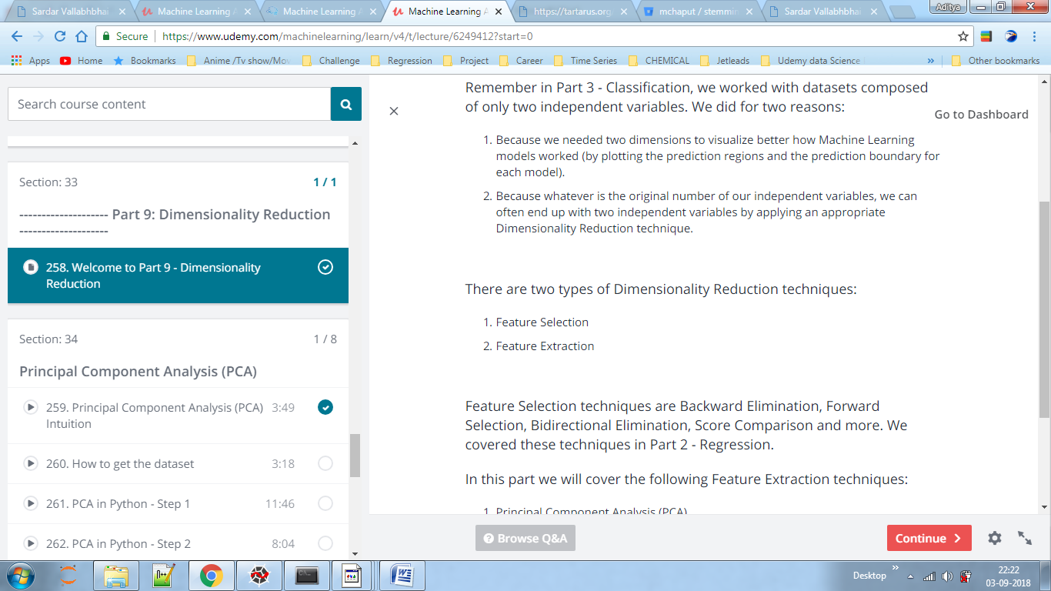

PCA – It is greatly affected by the outliers and also is different from linear regression because it co-relates between X and Y values.

PCA removes the redundant variables i.e. the variables which are not much useful for calculating the dependent variable.

It is unsupervised model .

https://stats.stackexchange.com/questions/2691/making-sense-of-principal-component-analysis-eigenvectors-eigenvalues

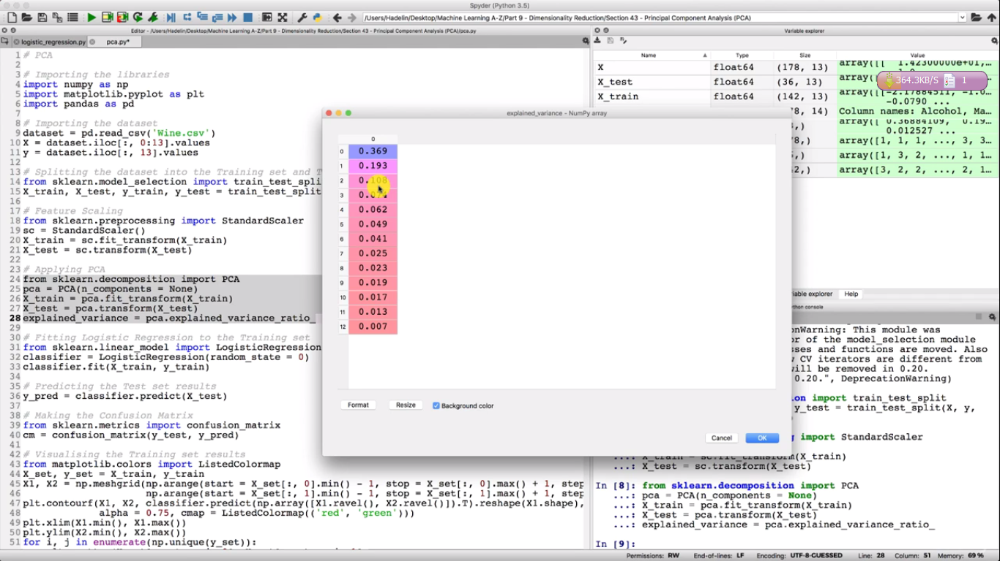

Here after running select code the variance shown is cumulative i.e for 2nd the variance is 1st +2nd value.

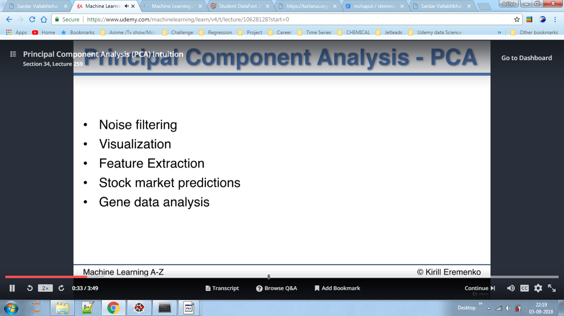

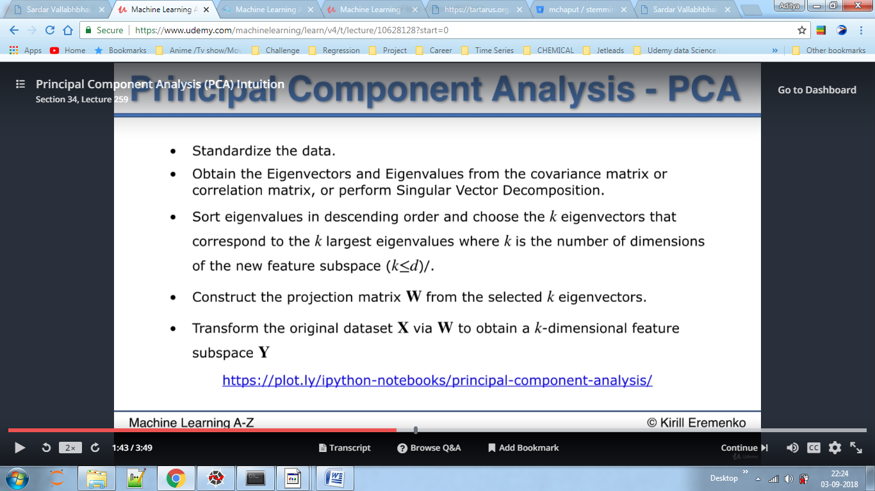

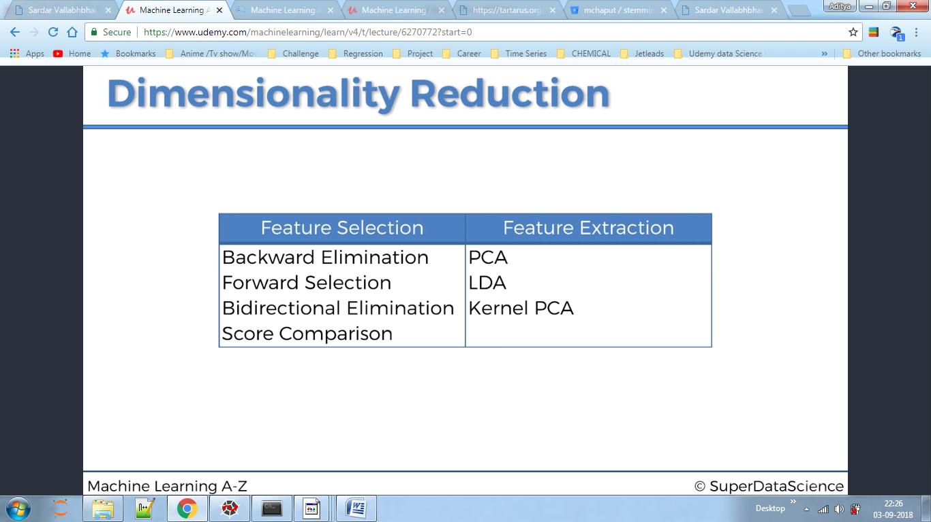

LDA-Supervised, uses y_train for training data, linear model, not like kernel which is non-linear in nature

